**The Significance Of Recycling Your Hard Drive**

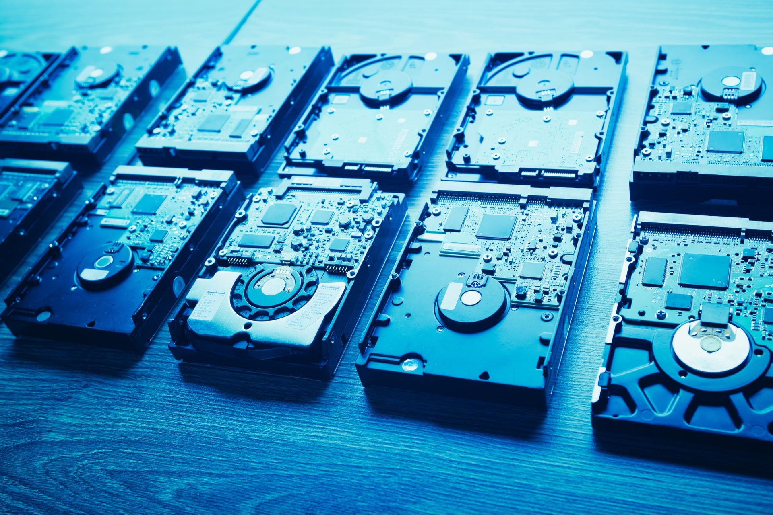

A user's hard disc should survive between 3 and 5 years on average. Typically, organisations that invest in new electronics do so in bulk; as a result, when a hard drive's lifespan expires, the troubles that come with it tend to have a significant influence on a workspace.

Some firms continue to try to drive ageing hard drives into the ground; however, this strategy is ineffective and may affect daily operations.

Here's when you should get rid of your outdated hard drives and invest in a better future for your company or institution.

**Is Your Hard Drive Nearing the End of Its Life?**

There are a variety of reasons why an organisation would need to submit outdated hard drives to an electronics recycling centre. However, there are a few telltale signals that it's time to start shopping for new equipment for your business.

**Due to computer malfunctions, productivity was lost**

As hard drives begin to exhibit symptoms of wear and tear, computers will develop issues that will impede your productivity. Old hard drives can cause problems ranging from the blue screen of death to laptops locking up, leaving your staff unproductive for hours, if not days, if the troubles have accumulated.

**Corrupted Files**

If your team is experiencing data corruption and difficulty accessing crucial files on a regular basis, it's time to upgrade your hard drives.

The following are some signs of corrupted files that signal a trip to the computer recycling centre:

* Names of scrambled folders
* Files missing
* Files that won’t open
* Data generally corrupted

**Unusual Sounds**

The sounds of clicking, grinding, and screeching are all signs that your hard drives are about to fail. It's only a matter of time before these loud faults lead to permanently defective equipment, from the head trying and failing to write data to fail spindle motors.

**Overheating**

A hard drive that is overheating is considerably more than it appears. When a hard drive fails and overheats repeatedly, data can become corrupted, and elements of the computer's circuit board can melt.

**When a hard drive fails, why should you recycle it?**

While it may be tempting to simply replace and save your old hard drives for a rainy day, the truth is that they will rot in storage and contribute to local E-waste.

Recycling outdated devices helps to give your equipment a new lease of life while also ensuring the security of your data through our rigorous data deletion process.

If you don't sit on your old equipment for too long, you can enjoy some cash rewards in addition to reducing your company's environmental footprint. Our staff specialises in purchasing and selling newly retired electronics for top price.

**With Recycle Pro, you can start reaping the benefits of recycling right now**

We'd want to hear from you if you think it's time for your company to retire its outdated hard drives. We make pickups and deliveries simple at [Recycle Pro](https://www.recyclepro.co.uk/), so you never have to worry about losing money on obsolete equipment or causing environmental damage due to incorrect disposal.

Contact us today to learn more about our services and to arrange for your first recycling pick-up from our team of experts.